ADVANCED PYTHON PROGRAMMING

NAME : G S Vithun

REG NO : 22MID0099

ERRORS:

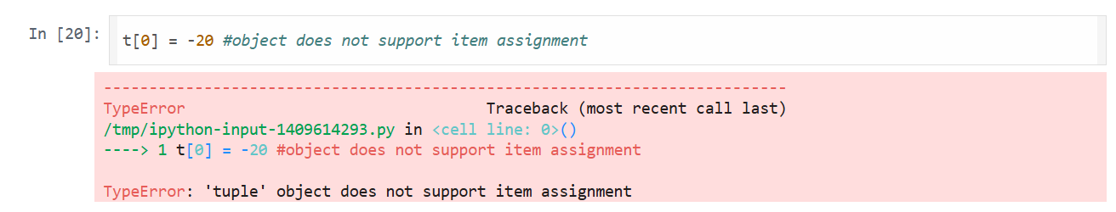

ERROR: Object not support item assignment

Solution : Tuple is Immutable